**Module 1 Lesson 1**

**Introduction**

This chapter introduces computer graphics quite broadly and from several perspectives: its applications, the various fields that are involved in the study of graphics, some of the tools that make the images produced by graphics so effective, some numbers to help you understand the scales at which computer graphics works, and the elementary ideas required to write your first graphics program. We’ll discuss many of these topics in more detail elsewhere in the book.

**1.1An Introduction to Computer Graphics**

**Computer graphics** is the science and art of communicating visually via a computer’s display and its interaction devices. Most simply, computer graphics are **pictures** that are generated by a computer. The visual aspect of the communication is usually in the computer-to-human direction, with the human-to-computer direction being mediated by devices like the mouse, keyboard, joystick, game controller, or touch-sensitive overlay. However, even this is beginning to change: Visual data is starting to flow *back* to the computer, with new interfaces being based on computer vision algorithms applied to video or depth-camera input. But for the computer-to-user direction, the ultimate consumers of the communications are human, and thus the ways that humans perceive imagery are critical in the design of graphics1 programs—features that humans ignore need not be presented (nor computed!). Computer graphics is a cross-disciplinary field in which physics, mathematics, human perception, human-computer interaction, engineering, graphic design, and art all play important roles. We use physics to model light and to perform simulations for animation. We use mathematics to describe shape. Human perceptual abilities determine our allocation of resources—we don’t want to spend time rendering things that will not be noticed. We use engineering in optimizing the allocation of bandwidth, memory, and processor time. Graphic design and art combine with human-computer interaction to make the computer-to-human direction of communication most effective.

Computer graphics is a very appealing field of study. You learn to write programs that create pictures, rather than streams of text or numbers. Humans respond readily to pictorial information, and are able to absorb much more information from pictures than from a collection of numbers. Our eye-brain systems are highly attuned to recognizing visual patterns. Reading text is of course one form of pattern recognition: we instantly recognize character shapes, form them into words, and interpret their meaning. But we are even more acute when glancing at a picture. What might be an inscrutable blather of numbers when presented as text becomes an instantly recognizable shape or pattern when presented graphically. The amount of information in a picture can be enormous. We not only recognize what’s “in it”, but also glean a world of information from its subtle details and texture.

In this chapter,we discuss some application areas, how conventional graphics systems work, and how each of these disciplines influences work in computer graphics.  
**A narrow definition of computer graphics** would state that it refers to taking a model of the objects in a scene (a geometric description of the things in the scene and a description of how they reflect light) and a model of the light emitted into the scene (a mathematical description of the sources of light energy, the directions of radiation, the distribution of light wavelengths, etc.), and then producing a representation of a particular *view* of the scene (the light arriving at some imaginary eye or camera in the scene). In this view, one might say that graphics is just glorified multiplication: One multiplies the incoming light by the reflectivities of objects in the scene to compute the light leaving those objects’ surfaces and repeats the process (treating the surfaces as new light sources and recursively invoking the light transport operation), determining all light that eventually reaches the camera. (In practice, this approach is unworkable, but the idea remains.) In contrast, computer vision amounts to *factoring*—given a view of a scene, the computer vision system is charged with determining the illumination and/or the scene’s contents (which a graphics system could then “multiply” together to reproduce the same image). In truth, of course, the vision system cannot solve the problem as stated and typically works with assumptions about the scene, or the lighting, or both, and may also have multiple views of the scene from different cameras, or multiple views from a single camera but at different times.

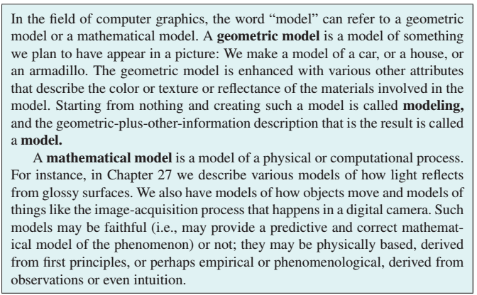

* + 1. **The World of Computer Graphics**

The academic side of computer graphics is dominated by SIGGRAPH, the Association for Computing Machinery’s Special Interest Group on Computer Graphics and Interactive Techniques; the annual SIGGRAPH conference is the premier venue for the presentation of new results in computer graphics, as well as a large commercial trade show and several collocated conferences in related areas. The SIGGRAPH proceedings, published by the ACM, are the most important reference works that a practitioner in the field can have. In recent years these have been published as an issue of the ACM Transactions on Graphics.

Computer graphics is also an industry, of course, and it has had an enormous impact in the areas of film, television, advertising, and games. It has also changed the way we look at information in medicine, architecture, industrial process control, network operations, and our day-to-day lives as we see weather maps and other information visualizations. Perhaps most significantly, the graphical user interfaces (GUIs) on our telephones, computers, automobile dashboards, and many home electronics devices are all enabled by computer graphics.

**1.1.2 Current and Future Application Areas**

Computer graphics has rapidly shifted from a novelty to an everyday phenomenon. Even throwaway devices, like the handheld digital games that parents give to children to keep them occupied on airplane trips, have graphical displays and interfaces. This corresponds to two phenomena: First visual perception is powerful, and visual communication is incredibly rapid, so designers of devices of all kinds want to use it, and second, the cost to manufacture computer-based devices is decreasing rapidly. (Roy Smith [Smi], discussing in the 1980s various claims that a GPS unit was so complex that it could never cost less than $1000, said, “Anything made of silicon will someday cost five dollars.” It’s a good rule of thumb.)

The camera takes multiple photos of a single scene,  
illuminated by differently placed flash units. From these various images, one can use computer vision techniques to determine contours and estimate some basic shape properties for objects in the scene. These, in turn, can be used to create a  
non-photorealistic rendering of the scene, as shown in Figure 1.1. 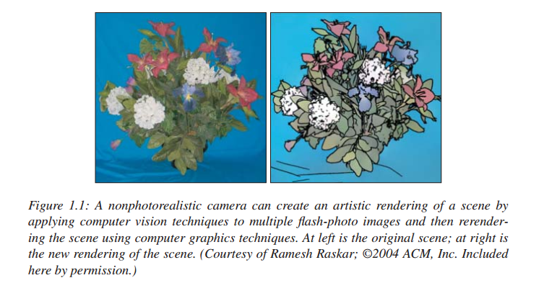

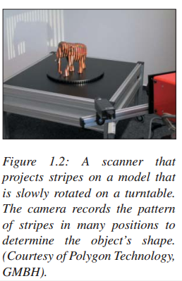As graphics has become more prevalent, user expectations have risen. Video games display many millions of polygons per second, and special effects in films are now so good that they’re no longer readily distinguishable from non-computer-generated material. Digital cameras and digital video cameras give us huge streams of **pixels** (the individual items in an array of dots that constitutes the image2) to be processed, and the tools for processing them are rapidly evolving. At the same time, the increased power of computers has allowed the possibility of enriched forms of graphics. With the availability of digital photography, sophisticated scanners (Figure 1.2) , and other tools, one no longer needs to explicitly create models of every object to be shown: Instead, one can scan the object directly, or even ignore the object altogether and use multiple digital images of it as a proxy for the thing itself. And with the enriched data streams, the possibility of extracting more and more information about the data—using techniques from computer vision, for instance—has begun to influence the possible applications of graphics. As an example, camera-based tracking technology lets body pose or gestures control games and other applications (Figure 1.3). 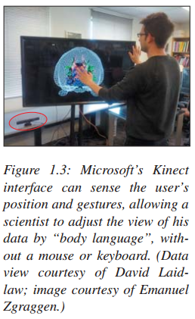

While graphics has had an enormous impact on the entertainment industry, its influence in other areas—science, engineering (including computer-aided design and anufacturing), medicine, desktop publishing, website design, communication, information handling, and analysis are just a few examples—continues to grow daily. And new interaction settings ranging from large to small form factors—virtual reality, room-size displays (Figure 1.4), wearable displays containing twin LCDs in front of the user’s eyes, multitouch devices, including largescale multitouch tables and walls (Figure 1.5), and smartphones—provide new opportunities for even greater impact. For most of the remainder of this chapter, when we speak about graphics applications we’ll have in mind applications such as video games, in which the most

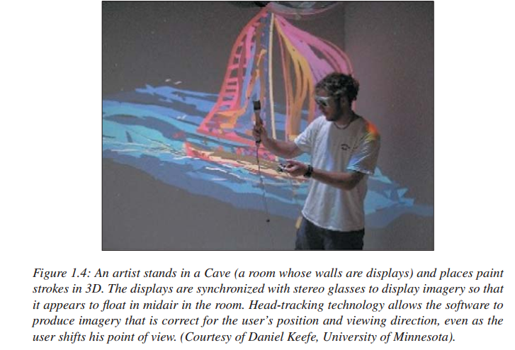

critical resources are the processor time, memory, and bandwidth associated with  
**rendering**—causing certain objects or images to appear on the display.

A useful measure of performance to keep in mind, therefore, is **primitives per second,** where a **primitive** is some building block appropriate to the application; for an arcade-like video game it might be textured polygons, while for a fluid-flow-visualization system it might be short colored arrows. The number of primitives displayed per second is the product of the number of primitives displayed per frame (i.e., the displayed image) and the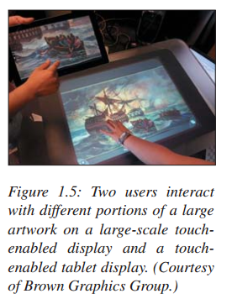 number of frames displayed per second. While some applications may choose to display more primitives per frame, to do so they will need to reduce their frame  
rates; others, aiming at smoothness in the animation, will want higher frame rates,  
and to achieve them they may need to reduce the number of primitives displayed  
per frame (or, perhaps, reduce the complexity of each primitive by approximating  
it in some way).

1.1.3 A GRAPHICS SYSTEM  
A computer graphics system is a computer system; as such, it must have all the  
components of a general-purpose computer system. Let us start with the high-level  
view of a graphics system, as shown in the block diagram in Figure 1.6. There are six  
major elements in our system:

**1.** Input devices  
**2.** Central Processing Unit  
**3.** Graphics Processing Unit  
**4.** Memory  
**5.** Frame buffer  
**6.** Output devices

This model is general enough to include workstations and personal computers,  
interactive game systems, mobile phones, GPS systems, and sophisticated image generation systems. Although most of the components are present in a standard  
computer, it is the way each element is specialized for computer graphics that characterizes this diagram as a portrait of a graphics system.

1.1.3.1 Pixels and the Frame Buffer

Virtually all modern graphics systems are raster based. The image we see on the output device is an array—the **raster**—of picture elements, or **pixels**, produced by the  
graphics system. 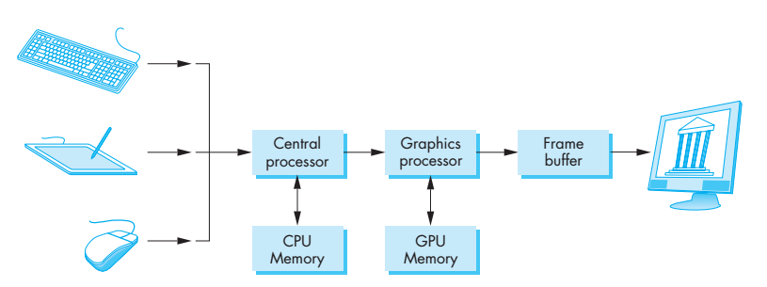

Figure 1.6 graphic system

Assignment 1

**Assignment**

1-Define each of the following terms:

* Computer Graphics
* Graphics Model
* Raster Display
* Geomatics model
* Mathematical Model
* Indexed Color and the LUT
* Frame buffer
* Frame buffer depth

2- The main component of the Computer Graphics system